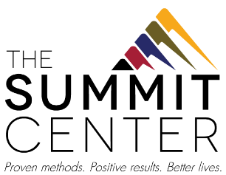
No Solicitation List
(Revised July 2021)

Actuarial Consulting Services, Inc.
American Eagle Fireplace & Playsets
Barclay Damon
Beechwood Continuing Care
Buffalo Bills
Buffalo Sabres
Buffalo Scrubs
Business First
Coca-Cola Bottling Co.
Copier Fax Business Technologies
Dent Neurologic Group
GEICO
Highmark Blue Cross Blue Shield of Western New York
Hodgson Russ LLP
Independent Health
Ingram Micro
Kenney Shelton Liptak Nowak LLP
La Nova
Lawley
Lippes Mathias Wexler Freedman
M&T Bank
Molina Healthcare of New York, Inc.
Mollenberg-Betz Inc.
New Era Cap Co.
North Forest Office Space
Owl Orthodontics
Perry’s Ice Cream
PCI
Rane Property Management
Reeds Jenss
Rich Products Corporation
Rite Aid
Sandhill Investment Management
Tim Hortons
Tops Markets
Uniland Development Company
West Herr Automotive Group

