Prevocational And Community Experience (P.A.C.E)
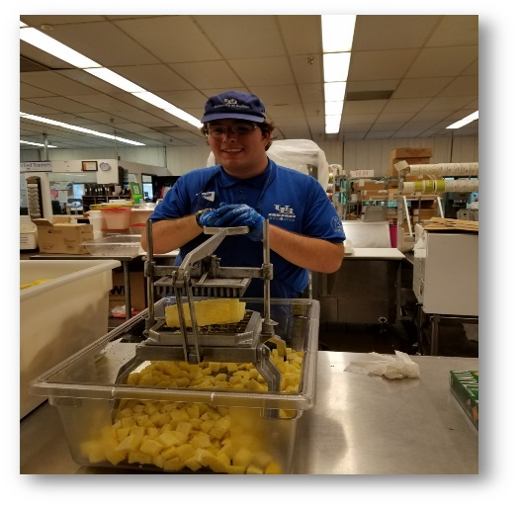

P.A.C.E. is a community-based Prevocational program that supports individuals with developmental disabilities in becoming active members of the community. Participants will work alongside staff and an Employment Specialist to gain transferrable skills through an unpaid internship.

Typical Day
7:30 - 8:00 a.m. Transport (Personal, Paratransit, or Public Bus)
8 - 8:30 a.m. Arrival
8:30 - 9 a.m. Morning Meeting/Lesson Plan
9 - 11 a.m. Morning Tasks
11-11:30 a.m. Lunch
11:30 - 1:30 p.m. Afternoon Tasks
1:30 - 2:30 p.m. Transport (Personal, Paratransit, or Public Bus)

Our staff
Program participants at both locations are supported by a professional, trained Employment Specialist
Program locations:
- UB Campus Dining and Shops (North Campus)
- Buffalo State College Bengal Kitchen (Chartwells)

Eligibility Criteria:
- Adults 18 years and older who are approved for services through the New York State Office for People with Developmental Disabilities (OPWDD).
- Individual must have available, reliable transportation to and from location (i.e.: PALS, family member, public transportation, etc.)
- Individual has basic communication skills.
- Individual must have suitable social, grooming and hygiene skills and adhere to dress code.
- Individual must be independent with toileting and feeding skills.
- Individual can be left unsupervised for brief periods of time.
- Summit staff cannot administer medication at P.A.C.E.
FOR MORE INFORMATION:
Call The Summit Center at 716.629.3400 or visit TheSummitCenter.org.

