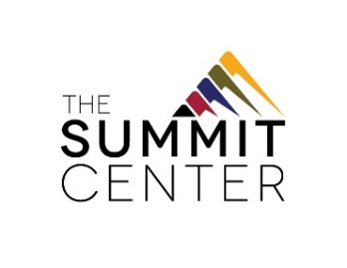
Success Through Engagement and Positive Supports (S.T.E.P.S)
Day Habilitation without Walls

S.T.E.P.S. is a community-based day habilitation program without walls that supports individuals with developmental disabilities in becoming active members of the community. Participants make friends, participate in community outings and recreational activities, volunteer for different local organizations, and learn skills that lead to greater independence. Every S.T.E.P.S. location serves up to 12 participants who are supported by five staff.
Typical Day
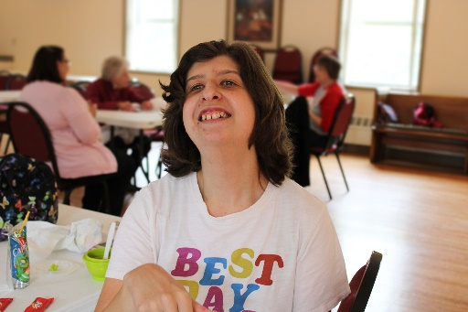
8:15 a.m. Morning Transport (provided)x
9:30 a.m. Morning Meeting
10 a.m. Morning Activity
11:30 a.m. Lunch
12:30 p.m. Afternoon Activity
2:30 p.m. Afternoon Transport (provided)

Our staff Program participants at all locations are supported by a professional, caring staff of Supervising Life Skills Trainers, Life Skills Trainers, and Behavior Support professionals.
Our locations: The Summit Center operates S.T.E.P.S. in convenient, community locations:
- S.T.E.P.S. Tonawanda #1: St. Clare Center 1st Floor – St. Francis of Assisi Church, 144 Broad Street, Tonawanda, NY 14150
- S.T.E.P.S. Tonawanda #2: St. Clare Center 2nd Floor – St. Francis of Assisi Church, 144 Broad Street, Tonawanda, NY 14150
- S.T.E.P.S. Eggertsville: St. Paul’s Lutheran Church, 4007 Main Street, Buffalo, NY 14226
- S.T.E.P.S. North Tonawanda: Renewal Church, 530 Meadow Drive, North Tonawanda, NY 14120

Eligibility:
- Participant must be at least 18 years old and eligible for services through the New York State Office for People with Developmental Disabilities (OPWDD).
- Service includes transportation to and from program, and to community activities throughout the program day.
- S.T.E.P.S. is provided in a community setting and individuals must be able to safely participate in this type of setting.
- Individual must live within 10 miles of S.T.E.P.S. location to be eligible for Summit-provided transportation.
- Summit cannot administer medication at S.T.E.P.S.
- Individuals should be able to toilet independently.
FOR MORE INFORMATION:
Call The Summit Center at 716.629.3400 or visit www.TheSummitCenter.org

