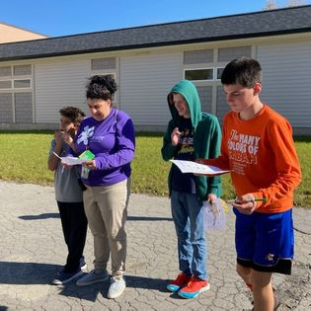
150 Stahl Road, Getzville, NY 14068
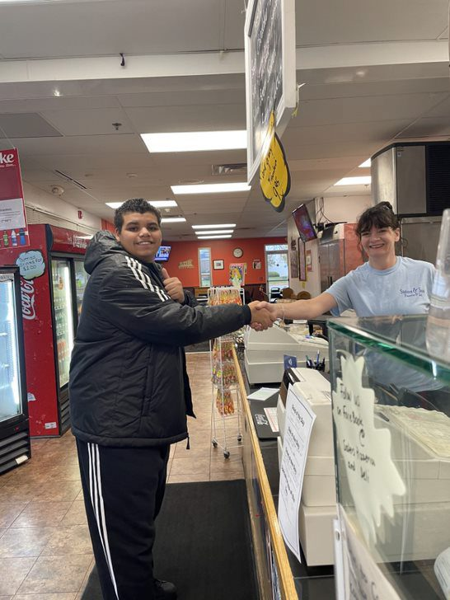

2025-2026
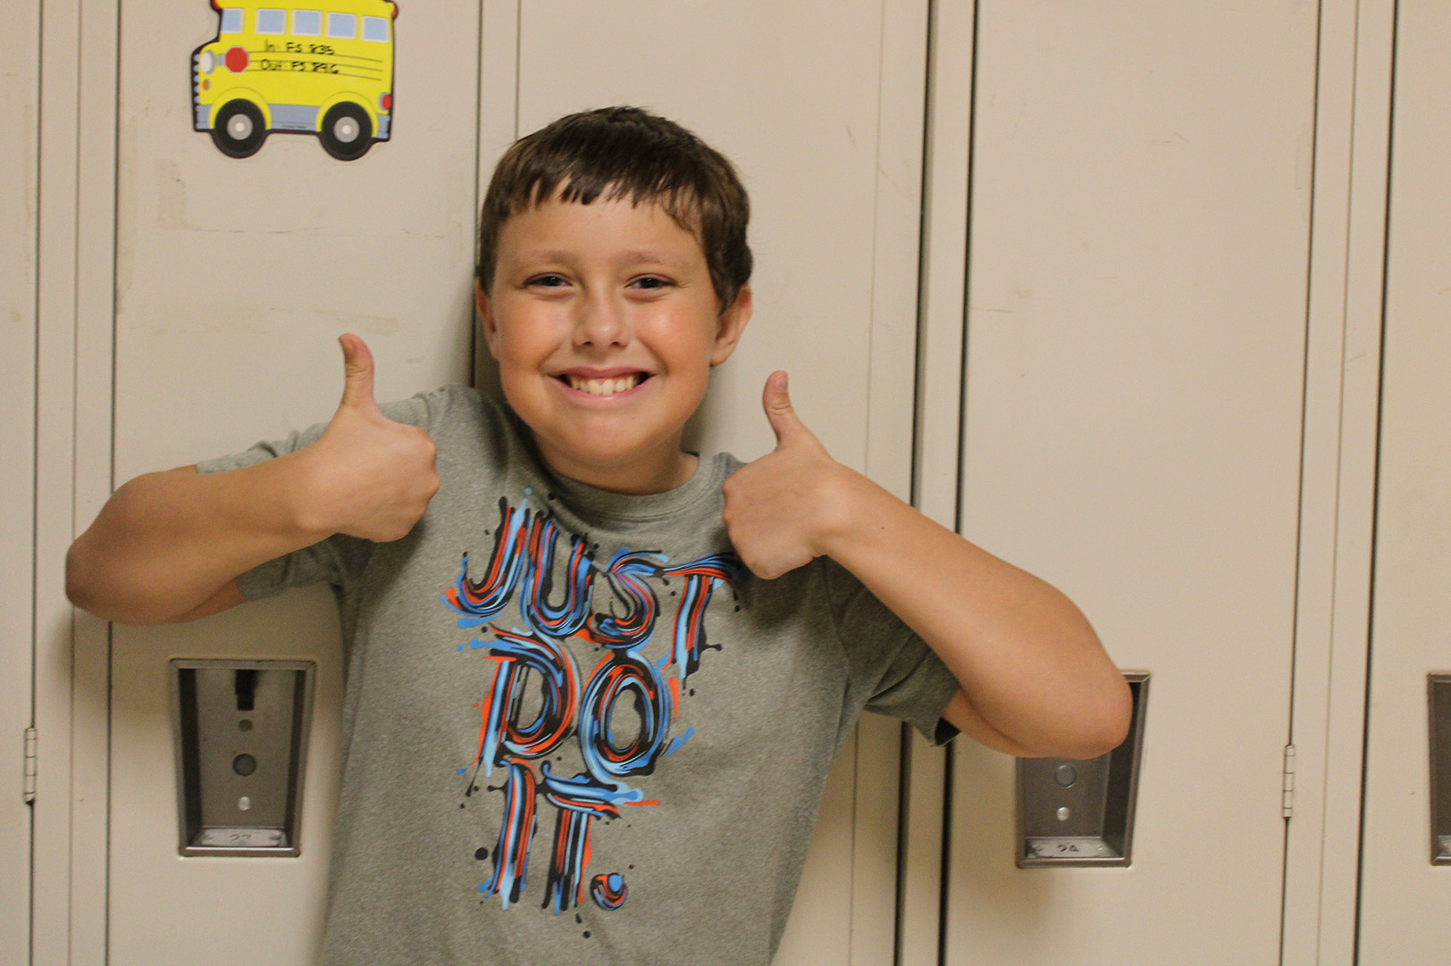
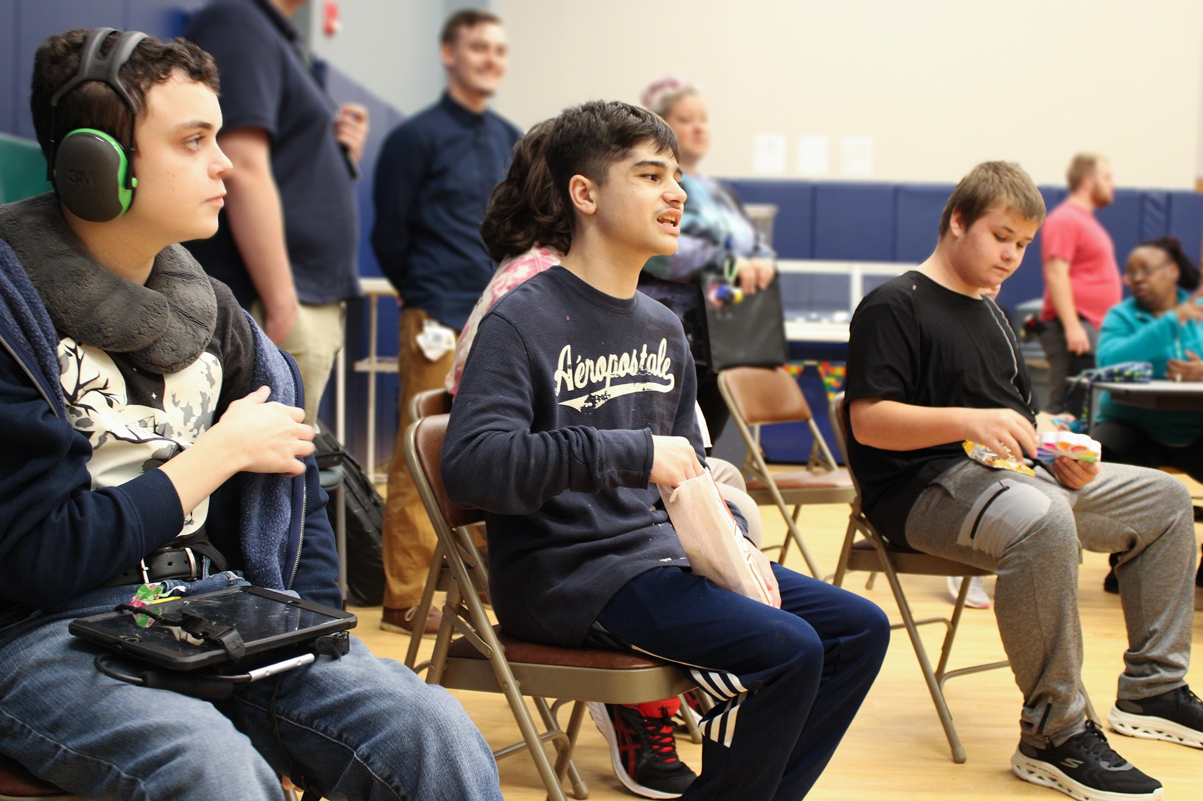

SUMMIT ACADEMY
Parent Handbook
www.TheSummitCenter.org


Dear Summit Academy Families and Caregivers,

My name is Mary Bennett, and I am proud to be the Superintendent of Schools for Summit Academy. I have worked for Summit for the past 20 years, first as a teacher in the classroom and then in various leadership roles, overseeing different aspects of our educational program. It has been a privilege to work with many dedicated staff and wonderful students over the years.

Our Summit Academy team and I welcome you and your child to a year of learning and progress. Please accept this Parent Handbook as a “go to” spot to answer questions regarding general information and policies regarding our school. We hope that it serves as a valuable resource throughout the school year. Your child’s educational team will work with you to establish a system for on-going communication with us throughout the year. Parent communication is essential for ensuring our students make progress and reach their goals.
Summit is committed to a team approach as we provide the care and services for each student’s educational journey. In this regard, YOU are an important factor to their success! The team supporting your child includes administrative leadership, teachers, teacher assistants, classroom aides, speech and language therapists, occupational therapists, physical therapists, behavior support, and many more. The orchestration of these services is guided by your child’s Individual Education Program (IEP) and each building’s systems for collaboration and communication.
In addition to the education your child receives from Summit Academy, many other services and supports are available to you through The Summit Center’s Behavioral Health, Community, and Adult Divisions. Information about these services can be found on Summit’s website at www.TheSummitCenter.org.
Thank you in advance for taking the time to review the information enclosed in this packet. Together, we make the difference!

Sincerely,
Mary Bennett
Mary Bennett, M.S.Ed, SBL, SDL
Summit Academy Superintendent

Contents
ABOUT SUMMIT ACADEMY 4
CODE OF CONDUCT 4
CURRICULUM AND INSTRUCTION 4
ANNUAL REVIEW PROCESS 5
REPORT CARDS 5
CREATING A CULTURE OF INCLUSION AND CELEBRATING DIVERSITY 5
RELATED SERVICES 5
SPECIAL AREA SUBJECTS 6
ARRIVAL/DISMISSAL AND BUS TRANSPORTATION 7
ATTENDANCE 7
HEALTH OFFICE 7
ALLERGIES 8
STUDENT INJURY 8
EMERGENCY RESPONSE TEAM 9
EMERGENCY DRILLS 9
BEHAVIOR MANAGEMENT STRATEGIES 9
CAMERAS IN THE CLASSROOM 10
HOME-SCHOOL COMMUNICATION 10
SHARING CONCERNS OR QUESTIONS WTH THE EDUCATIONAL TEAM 11
CHILD PROTECTIVE SERVICES 11
CUSTODY INFORMATION 11
STUDENT RECORDS 11
VISITING SCHOOL 11
SCHOOL SAFETY 12
E-ALERT SYSTEM 12
SCHOOL CLOSING INFORMATION 12
SOCIAL MEDIA 13
PARENT INVOLVEMENT 13
PRIVATELY-OWNED TECHNOLOGY AT SCHOOL 14
FOR FAMILIES AND CAREGIVERS OF STUDENTS 14 AND OLDER 14
NOTIFICATION OF RIGHTS UNDER FERPA 16
IMPORTANT PHONE NUMBERS 18

ABOUT SUMMIT ACADEMY

Summit Academy, a program of The Summit Center, provides year-round specialized educational and related therapeutic services to students (ages 3 – 21) with autism and other developmental, behavioral and communication challenges.

Founded in 1973 by Nancy Harris as The Language Development Program, Summit Academy has grown significantly from its very humble beginnings. Originally serving four students - including her own son - in Mrs. Harris’s home kitchen, Summit Academy now serves nearly 450 students with a staff of more than 400 professionals at four locations in Getzville, Amherst and Buffalo. Summit Academy on Stahl Road houses our preschool and elementary classrooms, Summit Academy on Creekside Drive serves our middle school students, and Summit Academy on Hazelwood Drive serves our high school students. Our school on Elmwood in Buffalo also serves our late middle and high school students, with an emphasis on vocational and community training. Summit Creekside is also home to Summit Academy Enhanced, a highly specialized educational setting for students with severe challenging behavior.

Summit Academy and Summit Academy Enhanced provide a positive, nurturing environment using evidence-based teaching methods to help promote positive results and continuing progress for your child. We look forward to working with you and welcome you to our school!

CODE OF CONDUCT

Summit Academy is committed to promoting a safe and orderly school environment where students may receive, and school personnel may deliver, quality educational services without disruption or interference. Responsible behavior by students, teachers, other school personnel, parents and other visitors is an essential element to achieving this goal. Summit’s Code of Conduct meets the requirements outlined in The New York State Regulations of the Commissioner of Education part 200.7(b)(3).

The Summit Academy Code of Conduct is located on Summit’s website, www.thesummitcenter.org, under the “View Summit Parent Information” section.
CURRICULUM AND INSTRUCTION

Summit Academy is committed to helping all students reach their full potential through instruction that is evidence based and developmentally appropriate. Instruction is based on students’ strengths and preferences in order to build upon what the student can already do and likes to do. Teachers then work with parents/caregivers to determine skills that the student is ready to learn and that will help them become more independent and successful. Teaching based on the principles of ABA has been shown to be the most effective way to help children and young adults learn to communicate, to become more independent in daily living and self-help skills, and to learn academic skills and social skills. This research lays the foundation for the education we provide.

Summit Academy’s curriculum options allow for each child to have a fully individualized and comprehensive curriculum. Our primary curriculum, called SummitUP™, addresses all areas of development including Academics, Self-Management Skills, Communication, Community Skills, Daily Living Skills, Motor Skills, Self Help, Social Skills, and for our older students, Vocational Skills. Supplemental curricula that are offered in addition to SummitUP include Healthy Relationships which is used to teach self-help and social skills using a variety of teaching methodologies. In addition, Everyday Speech is used to enhance social skills instruction. Finally, in order to expand literacy education, we have adopted Edmark Reading and Unique Learning Systems and Jolly Phonics for the integrated preschool students.

ANNUAL REVIEW PROCESS

Each year, your child’s transdisciplinary team will contact you to discuss your child's Individual Educational Program (IEP) goals/objectives and program needs for the upcoming year. We strongly recommended that you participate in these discussions so that you have an opportunity to provide crucial input and feedback. Teachers and therapists may seek your input through phone calls and/or forms designed for you to share your goals and priorities for your child’s IEP. Beginning at age 14, and continuing each year thereafter, Measurable Post-Secondary Goals for your child (which are included on your child's IEP) are also discussed.

Your school district will schedule an annual CPSE (Committee of Preschool Education) or CSE (Committee of Special Education) meeting to discuss your child’s IEP for the upcoming school year. It is very important to have parent participation at this meeting. After your child’s CPSE or CSE (Committee of Special Education) meeting, the district will provide a copy of the finalized IEP.

REPORT CARDS

Student report cards are sent home quarterly. You are always welcome to contact your child’s teacher to arrange a parent-teacher conference.

CREATING A CULTURE OF INCLUSION

Summit Academy is committed to fostering, cultivating, and preserving a culture of individual and collective strength for our staff and the individuals we serve. We have a council of individuals who are consistently reviewing our approach and practices, with the intention of advancing our school's culture by creating a safe environment where individuals are supported, respected, and valued, free of judgment. The collective sum of the individual differences, life experiences, knowledge, inventiveness, innovation, self-expression, unique capabilities, and talent that our employees invest in their work represents a significant part of not only our culture, but our reputation and achievement as well.

Our goal at Summit is to foster, cultivate and preserve a culture of diversity and inclusion while celebrating our individual and collective strength. We embrace and respect our employees’ and students’ differences. We recognize and uphold the rights of the employees and students we serve.

RELATED SERVICES

Related service practitioners (speech therapists, occupational therapists, and physical therapists) provide services to students using a variety of service delivery models including individual service, group service and consultative service, as specified on the student’s IEP.

Occupational Therapy
The goal of occupational therapy is to help students participate fully in school activities including academics, self-care skills, play and leisure, home management skills, social participation, health management, and transition and work skills. Occupational therapists do this by evaluating strengths and barriers in cognitive skills, motor skills and social-emotional skills as well as the student-environment fit. Occupational therapists look at the supports that already exist and what supports are needed to bridge those gaps and allow students to progress from their individualized curriculum.

Speech Therapy
Speech-Language Pathologists (SLPs) and Teachers of Students with Speech and Language Disabilities (TSSLDs) assist students by improving their ability to functionally communicate within their environment. They constantly assess, evaluate, and practice utilizing a student’s current speech-language abilities to create supports to further develop a student’s language. For many of our students, our therapists will determine if augmentative and/or alternative communication (AAC) method(s) would promote a student’s independence, self-determination, and socialization with their community. Our AAC Supervisor assists therapists, students, and parents on navigating augmentative or alternative communication methods.

Physical Therapy
Summit Academy offers physical therapy services to students with physical impairments that limit their independence in the school setting. These services are delivered by a licensed physical therapist (PT) or physical therapy assistant (PTA), both of whom are integral members of the educational team. The primary aim of physical therapy within the school setting is to enhance a student's engagement throughout the school day. A school-based physical therapist considers participation beyond the classroom, addressing various environments such as the gym, playground, cafeteria, hallways, and fitness room.

SPECIAL AREA SUBJECTS

Adapted Physical Education (APE)
Summit Academy offers APE for students with disabilities, modifying activities to meet individual needs. This program provides students with skills for lifelong leisure, recreation, and sport experiences. Each month a unit of activities is assigned that our students participate in. These units are designed to address a wide variety of gross motor skills and patterns. Activities are broken down further to work on individual skills and components that can be brought together for more successful group games and activities. Many of our units are transferred into a community setting for recreational opportunities. Each Summit location is equipped with a gymnasium and adapted equipment and all school-age students at Summit Academy participate in APE.

Creative Arts
The Summit Academy Creative Arts program seeks to provide our students with experiences that encompass a variety of creative arts disciplines. They will explore and experience visual arts, music arts, as well as performing arts. While we realize some students may have educational or behavioral goals that supersede these fields or may have safety/sensory reasons to avoid these fields, we strive to provide access to all students in Academy. Creative Arts classes offer students the chance to practice and generalize skills in every area of learning but are especially beneficial for OT and Social Emotional goals. We seek to instill in our students a lifelong appreciation for how the Creative Arts can enhance their lives, and the skill sets needed to incorporate them into their adult lives as independently as possible.

Charlie Rothman Media Center
In the Charlie Rothman Media Center, we aspire to promote a love of books in our students. Through storytelling, reading programs, book fairs and other events, we hope to encourage student curiosity and a lifelong enjoyment of books and other media as leisure items.

The Media Center also provides Summit staff with materials and resources needed to support student work in all curriculum areas. This includes facilitating staff and student access to iPads and applicable support, educational software, and curriculum materials.
ARRIVAL/DISMISSAL AND BUS TRANSPORTATION

All families receive a detailed packet regarding transportation to and from school that contains information about arrival, dismissal, late arrival, early dismissal, bussing and parent drop off procedures, and hours of operation. Please review this information carefully as it contains important information regarding the procedures specific to your child’s school.

Please note that if your child is to be released from school at any time to anyone other than their parent, you must send a written note to your child’s teacher. We CANNOT release a child to anyone other than the custodial parent without the custodial parent’s permission. Photo identification must be presented at dismissal and can be requested at any time (even if the parent has picked up in the past).

Please note that bus transportation is arranged by your child’s home district. Summit staff and supervisors will work to support the bus company and your child by providing training and creating student-specific protocols for your child when needed. If you have concerns about the bus, please contact your child’s bus company and school district.

ATTENDANCE

New York State Education Law requires that students attend school every day it is in session unless they are legally excused. Regular school attendance and punctuality are essential for a child to make continuous progress. Parents can help their child succeed by ensuring attendance except when ill or in the event of a family emergency. If you are encountering difficulties in getting your child to school regularly, please contact the educational team for support.

IF YOUR CHILD WILL BE ABSENT FROM SCHOOL, PLEASE CALL THE STUDENT ATTENDANCE CALL IN LINE TO REPORT THE ABSENCE AT (716) 629-3420. It is very important that you notify the school of absences.

A written excuse is necessary when a student returns to school. In some cases of illness or injury, a medical release will be required before your child can return to school. A written excuse must be received within one week or the absence will be considered unexcused (or illegal).

Excused (legal) absences include:
· Personal Illness
· Illness or death in the family
· Medical appointments
· Religious observance
· Required court appearances
· Impassable roads or weather
· Late bus
· Approved programs or alternate schooling

The total number of your child’s absences will appear on your child’s progress report and will be sent to your district. Your child’s school district will be notified if your child demonstrates a pattern of excessive absences.

HEALTH OFFICE

At the start of the school year, families and caregivers will receive information pertaining to your child’s health and wellness at school. This information includes important forms to be completed and returned, information about vaccinations and physical examinations, screenings, medications, and our illness policy. PLEASE CAREFULLY REVIEW THIS INFORMATION WHEN IT IS SENT HOME AND COMPLETE ALL NEEDED FORMS. In addition, the illness policy must always be followed, so please ensure you are familiar with this information. Our procedures and policies are aligned with NYS regulations and common school practices and are reviewed by our school physician.

Please be aware that our nurses will deliver first aid for minor injuries, and during emergencies, they will provide recommendations and care as appropriate, per NYS regulations. Summit nurses work with families, classroom teams and supervisors to determine the appropriate course of action when a student needs medical attention for illness or suspected/confirmed injury. The school will make the final decision on whether a child needs to be picked up for illness or suspected/confirmed injury and/or requires follow up from a healthcare provider.

ALLERGIES

The risk of accidental exposure or cross-contamination is always present in school, particularly for students with food allergies. As such, Summit Academy is an “Allergy Sensitive” school, and our team will use reasonable care to monitor Summit Academy areas and activities. Our school does not serve known allergens as part of our meal program or during special events and cooking instruction. Products containing known allergens are not permitted within our classrooms and common instructional areas. If an item containing one of these allergens comes to school, we will discard it and inform you.
Please do not send any food or beauty or hygiene products containing the following ingredients to school:
· Peanuts
· Tree nuts
· Coconuts (often found in beauty or hygiene products)

If Your Child Has a Known Allergy
Summit Academy requires a doctor’s note with specific instructions if your child’s allergy may require specific health care intervention during the school day. If there is any change in your child’s medical information, including allergies, please inform us immediately.

STUDENT INJURIES

When a student sustains an injury, they are assessed by the Summit nurse. This may occur in the health office or in the classroom, depending on the situation. Basic first aid may be provided by the educational team. A student injury report is completed and kept on file; this is reviewed by the supervisor to prevent future occurrences. You will be notified and updated about the injury.

A very minor injury may not require a call to a parent in the nurse’s judgment. If this is not acceptable to you, please let us know. Also, please let us know how to best contact you (cell phone, office phone, home phone) during the school day. In addition to parent/guardian contact information, Summit must have updated information for emergency contacts.

In the event of a severe illness or injury, First Aid will be administered by the nurse or a member of our Emergency Response Team. Paramedics may also be called. Every effort will be made to contact a parent/guardian.

If your child has been injured outside of school and has limitations imposed by a doctor (e.g., no gym), a written note from the doctor is required. Please contact our Health Office before your child returns to school. In some cases, a series of physician generated documents may be required before return to school and/or therapy is possible.

EMERGENCY RESPONSE TEAM

Summit Academy’s Emergency Response Team (ERT) responds to life-threatening emergencies during the school day. Our top priority is keeping students and staff safe while they are in the building. The ERT is trained in CPR and AED for adults, children, and infants and First Aid.
Situations or conditions that may warrant an ERT call include:
· any major disaster within close proximity to a Summit site
· cardiac emergencies
· food poisoning
· multiple severe injuries
· excessive bleeding (more than the size of one hand) - EXCLUDING NOSE BLEEDS
· severe allergic reaction
· head, neck or back injury
· drowning or near drowning
· unconsciousness
· choking
· fractures
· sudden illness (stroke, diabetes)
· seizures in a child that does not typically have seizures
· prolonged seizures (> 2 minutes)
· burns and severe wounds

ERT staff, at their discretion, may choose to call 911 if the situation warrants and will make all attempts to contact parents. If 911 is called, the 911 response team then takes charge of the situation and makes treatment decisions for the child.

EMERGENCY DRILLS

Per NYS regulations, Summit conducts evacuation and lockdown drills for all school buildings. Summit conducts 12 drills per school year, 8 of which are evacuation drills and 4 of which are lockdown drills. Additionally, 2 drills are completed for the summer school session. These drills are trauma-informed and designed to help students and staff practice ways to respond in an emergency, while in a supportive environment. Summit will notify families within 5 business days of any upcoming lockdown or evacuation drill, and will send home notification of lockdown drills on the day of the drill. Students who are non-ambulatory or do not transition easily during an emergency situation will have alternate plans in place, and staff will work with students to systematically address transition skills in these situations.

BEHAVIOR MANAGEMENT STRATEGIES

At Summit Academy, we treat every student with respect. We focus on proactive, effective, evidence-based strategies to address behavioral concerns that may interfere or impede with learning. All Summit Academy classrooms implement a classroom management plan (CMP) founded on the principles of a positive behavioral interventions and support model (PBIS). Classroom rules are based on students being safe, being respectful and kind and ready to learn. Minor challenging behaviors are met with prompts to communicate or redirection to an appropriate activity.
If a challenging behavior is not responsive to the CMP, our team (with parent involvement) will place a referral to the Committee on Preschool Special Education (CPSE) or Committee on Special Education (CSE) in order to complete a Functional Behavioral Assessment (FBA). This assessment will determine the function or reason why the behavior(s) is occurring and may recommend a behavior support plan (BIP) to decease your child's challenging behavior and teach replacement skills. Your participation throughout this process is very important to your child’s success.

Summit has developed a tiered model of support to ensure appropriate service levels are secured and communicated to parents and districts:

Tier One Support: At this tier, students can follow the CMP throughout the day and are not in need of an Individual Behavior Plan.

Tier Two Support: At this tier, students may have a BIP to decrease challenging behaviors that occur throughout the day. Additional support may be needed.

Tier Three Support: At this tier, students require a Behavior Intervention Plan to support consistent and frequent challenging behaviors that may impact safety to themselves, peers, and staff. Additional support is necessary to maintain safety.

Summit Academy Enhanced: In this program, students aged 13-21 will require a Behavior Intervention Plan as well as a smaller student to staff ratios of support, access to additional assessments, and a denser schedule of targeted treatment from behavior support professionals. This program requires a separate referral and admissions process.

If challenging behaviors arise at home, please talk with your child’s teacher to find out how we may be able to help. It’s not unusual for challenging behaviors that happen at school to also happen at home. Consistent implementation of a plan between home and school will help speed your child’s progress toward improved behavior.

CAMERAS IN THE CLASSROOM

Summit Academy classrooms are equipped with cameras that allow for video and audio monitoring and may record for internal purposes. The cameras are used for staff observations and training as well as security and parent observations. If you wish to schedule an observation of your child by camera, please contact the principal/director or assistant principal/director of your child’s school building.

HOME-SCHOOL COMMUNICATION

Communication between home and school is essential for your child’s continued progress. You may work with your child’s teacher to individualize the home-school communication log to help ensure that it contains the information that is most helpful for you and for your child’s teacher. Your child’s teacher will contact you early in the school year to set up a communication system that works best for you: communication notebook, phone calls, emails, text, etc. If at any time the communication system is not meeting your needs, please let your child’s teacher know. Each classroom also provides a newsletter that will inform you of classroom activities and upcoming events. Meetings and phone calls may be recorded by Summit staff for the purpose of accurate documentation.

All schools utilize Class Dojo to enhance communication between home and school. Information regarding Class Dojo is sent home at the beginning of the school year. We strongly encourage parents and primary caregivers to sign up and use the Class Dojo application. Please note that teachers may not respond during teaching hours to messages from families using the Class Dojo application. Urgent messages must be directed to reception (see Important Contact Information section).

SHARING CONCERNS OR QUESTIONS WITH THE EDUCATIONAL TEAM

Summit Academy is committed to providing quality services that are responsive to students’ individual needs. Concerns regarding services often can be handled more satisfactorily though direct communication with those involved. If you have a concern or complaint regarding services received, please bring the issue to the attention of the staff member directly involved with the situation (such as the student’s teacher or related service provider). If the matter is not successfully resolved at this level or if you do not feel comfortable informing the staff directly involved, please bring the unresolved issue to the attention of the building principal or unit assistant principal. The school administrator will formally address the matter and set up a meeting with you either in-person or by phone, within five business days.

CHILD PROTECTIVE SERVICES

Summit staff are required by New York State Law to report any suspicion of child abuse or neglect to the proper authorities. This does not mean the allegation has been proven, but that there is reasonable cause to suspect abuse/neglect may have occurred.. In some circumstances, Summit may notify you that a report has been made. Summit will fully cooperate with all Child Protective Service (CPS) investigations. CPS calls are confidential and anonymous, and Summit is not required to inform families when the school or a staff member has chosen to make a call.

CUSTODY INFORMATION

Summit Academy must have a copy of any current court ordered custody and/or visitation for your child. We CANNOT release a child to anyone other than the court-authorized parent/guardian without the court-authorized parent/guardian’s written permission.

If there are significant changes in your child’s home life, please share the information with your child’s teacher and/or the principal. It is important that we strictly adhere to this policy to help ensure the safety of our students.

STUDENT RECORDS

Summit Academy maintains student records throughout your child’s educational career with us. The Summit Center maintains confidentiality of all student records. If, at any time, you would like to review your child’s education record, please contact the Records and Clerical Team Member by calling (716) 629-3400. We delete and destroy records of former students for whom we have provided services in accordance with relevant state and federal law, including but not limited to the Family Educational Rights and Privacy Act and the Individuals with Disabilities Education Act.

VISITING SCHOOL

Please contact your child’s teacher if you wish to visit Summit Academy. Each building has their own practices associated with parent visits; however, we welcome families to participate in special events both in and out of school. If you would like to observe your child, please contact the assistant principal or principal of your child’s school building.

For safety, all doors at our Academy locations are locked throughout the day. To enter the building, please use the buzzer/phone at the main entrance. All visitors are required to sign in at the Reception Desk and pick up a visitor pass upon entering the building. (We may require you to show identification.) You will be greeted and escorted through the building by the individual that you have made the appointment with. The visitor pass must be worn at all times while visiting our school. Visitors must also sign out.

Keeping our students safe is of the utmost importance.

SCHOOL SAFETY

Summit Academy takes emergency preparedness very seriously. We have a comprehensive plan that helps our staff and public safety partners respond swiftly in the event of an emergency. Building-level plans are in place and drills are conducted regularly. We have an active Emergency Planning Committee that meets regularly to review our Plan and make improvements as needed to help ensure your child’s safety.

Our school buildings are prepared to keep your child secure and safe if a situation arises that prevents or postpones dismissal.

Please know that in the event of an emergency, we will first do what is necessary to protect our students and then inform you as accurately and fully as possible. Together with emergency response officials, we will make every effort to provide a steady, reliable flow of information using the E-Alert system, social media, and local media.

E-ALERT SYSTEM

Summit’s E-alert system allows you to receive text, phone, and/or email alerts about school closing information, emergency notifications, and other important announcements.

The Summit Center E-Alert System / School Messenger: Sign up to receive text, phone call and/or email alerts about building closing information, emergency notifications and other important messages directly to your phone! Visit https://www.thesummitcenter.org/parent-resource/e-alert-sign-up/ to sign up or scan the QR code below.

SCHOOL CLOSING INFORMATION

School closings will be shared through the e-alert system (see section above), social media, and news stations. Signing up for Summit Academy’s e-alert system is the easiest and quickest way to learn urgent information.

Social Media: School closing information will be posted on The Summit Center’s Facebook page as soon as a decision is made. Follow us at: https://www.facebook.com/TheSummitCenter.org
You can also refer to the following TV stations for school and/or program closing announcements:

WGRZ TV (CH. 2)
WKBW TV (CH. 7)
WIVB TV (CH. 4)
WNLO TV (CW23)

School and/or Program cancellations will be called into the above stations between 6:30 a.m. and 7 a.m. or as early as possible. E-Alerts will also be sent at that time. Closing announcements will pertain to either all locations or individual sites, depending on the reason for the closing. When ALL Summit Academy sites are closed at the same time, the announcement will be: “Summit Academy, all sites – CLOSED”, otherwise, the specific site will be announced.

Transportation companies will not transport pupils into or out of a school district that is closed due to inclement weather. If Summit Academy is open and your district is closed and not transporting, parent transportation to Summit is an option. Additionally, if you have a preschool child in a combination program, home-based services in the Early Autism Program (EAP) will not be delivered if your child’s home school district is closed. However, if your home district is open, we will attempt to provide EAP services.

Please note: Weather-related building closures are generally tied to the school districts in which they are located. For example, if:

Buffalo schools are closed - Summit Academy - Elmwood will be closed.
Sweet Home schools are closed - Summit Academy - Creekside & Hazelwood will be closed.
Williamsville schools are closed - Summit Academy - Stahl will be closed.

If the need arises for an early dismissal during the day, either due to storm conditions or other unforeseen circumstances, you will receive an e-alert notification if you have signed up. Otherwise, please watch the above stations. Authorized Summit staff members will also call parents/emergency contacts and bus transporters.

Bus routes CANNOT be altered during an EMERGENCY situation. Therefore, if you are NOT HOME during the day, please arrange NOW for someone to receive your child at the REGULAR DROP-OFF POINT!

Important: Television stations are not always timely and accurate in reporting school closings. Sign up for our Summit e-alert system for the quickest and most accurate way to receive information. You can also find information on our Facebook page - The Summit Center.

SOCIAL MEDIA

The Summit Center is active on Facebook (“Like” us at The Summit Center), X (follow us at @SummitBuffalo), Instagram (@SummitBuffalo) and LinkedIn (TheSummitCenter). Please note that all posts to these pages can be seen by all who follow the page. Therefore, please do not post personal or confidential information about your child, or information that is intended for your child’s teacher on social media.

PARENT INVOLVEMENT

Our administrative team continues to explore opportunities for increased parental involvement and engagement, including special events, volunteer opportunities for families, and an expanded voice in school decisions.

In addition, donating your time or treasure is a wonderful way to give back to Summit and the work we do each day. We are so grateful for you entrusting your child to our committed team of teachers, therapists, and behavior specialists. You may not realize this, but State Education funding does not cover all the expenses necessary to educate our students. The balance comes from engaged parents, loyal donors, community sponsors and funders.
We hope you will get involved in some way:
· Annual Fund – make a gift of your choosing to the spring appeal, fall appeal, or December campaign.
· The Summit Center Autism Walk – form a team or join the committee (held on a Saturday in mid-May).
· Party for Summit gala event – sponsorships, tickets, auction items, raffle tickets, volunteer opportunities (held in early November).
· Third Party “Summiteer” events: host an event or dress down day through your office or civic group and select Summit as a beneficiary. All “Summiteer” events require prior approval through our Developmental Office (www.thesummitcenter.org/summiteer/).
· DIY Fundraisers: create your own campaign to fundraise for Summit as you run a race or complete a challenge.
· Memorial and In Honor Of gifts to recognize loved ones and special occasions, including bricks on our tribute walkway at Summit Central (www.thesummitcenter.org/donate/tribute-gifts/).
· Sponsorship opportunities through your employer for Summit events.
· Philanthropic or Awareness fairs at your place of employment.
· Volunteer opportunities.
· Matching gifts through your employer.

Summit participates in many cause marketing promotions, including:
· Amazon Smile
· Embrace the Difference, exclusively at Reeds/Jenss
· Rite Aid KidCents – Healthy Futures
· Box Tops for Education
· Tops in Education
Visit our website for more information (www.thesummitcenter.org/other-ways-to-help/).
If you have any questions, please feel free to contact the Development Department at: (716) 629-3423 or email development@thesummitcenter.org. We look forward to connecting with you!
** Although financial assistance is appreciated, no parent is required to donate or provide financial help to Summit.

PRIVATELY-OWNED TECHNOLOGY AT SCHOOL

Summit Academy uses Summit-owned technology as well as technology devices owned by respective school districts. Insurance-funded devices and family-purchased devices are also used for educational programming. These devices can be very expensive and often fragile.

Any instructional technology device sent into school must be equipped with a protective case. Our staff takes every precaution to make sure that the technology is used safely and correctly, but due to the fragile nature of such devices in a school environment, Summit Academy will not be responsible for repairs to instructional technology devices sent into school. This includes damage caused by another student.

We ask that any devices, instructional or otherwise, moving between home and school are free of sensitive personal information as well as any information that has inappropriate content, including but not limited to photographs and websites. Please also be mindful of this when syncing devices coming to school with devices you have at home.

In addition, the classroom team supporting your child’s educational programming will review parental requests to have family-purchased instructional technology devices used during the school day. They will examine the appropriateness of, and how best to incorporate, a particular device into school day programming in the following areas: academic, communication, fine motor, leisure and reinforcement.

Depending on whether the device is owned by Summit, the district, and/or the family, you may receive a form outlining our policy or to help us determine the appropriateness of using such a device in school.

Some families may have privately-owned devices that are intended to record audio or track their child’s whereabouts. Please know that due to our confidentiality policies, these devices are not allowed in classrooms or instructional areas. If your child currently brings one of these devices to school, you must inform the school and your child’s belongings containing these devices will be stored in their locker.

Students are not permitted to carry cell phones into their classrooms or other instructional areas. If your child owns a cell phone and takes it to school, the phone will be stored in their locker. If your child’s cell phone contains applications that have communication or educational relevance, please contact your child’s building or unit supervisor to determine next steps.

FOR FAMILIES AND CAREGIVERS OF STUDENTS 14 AND OLDER

Transitioning to Adulthood
Summit provides transition support to students as they look toward their future. The transition process begins when a student reaches age 13. Transition discussions include a student’s vision and goals for post-graduation (i.e., independent living, continuing education, employment). As students prepare to transition to adulthood, the curriculum is designed to focus on independence with life skills, career exploration, and/or work-based learning. The transition plans target specific goals and continues to build academic, social, and motor skills. As families and caregivers, you will work closely with the multi-disciplinary team to annually assess, develop goals, and provide opportunities for your child to successfully transition into adult programs, post-graduation. As your child approaches graduation, we will work closely with you to secure an adult placement (i.e., supported employment, community pre-vocation, and/or day habilitation program) that is most appropriate for your child’s skill set and abilities.

Transition Department
Summit Academy’s transition department prepares students and their families/caregivers for life after graduation. Within school, the transition department works with secondary teachers to design objectives and implement programming that aligns with each student’s unique post-secondary goals. This includes managing and expanding work-based learning opportunities for students on a vocational path, as well as providing community and leisure opportunities for all transition-aged students. The transition team also works with parents and caregivers to manage the transition timeline, ensuring all necessary tasks are completed prior to graduation to make the transition from school to adult-services and/or work as smooth as possible.

Guardianship
Establishing guardianship is an important step as your child becomes an adult and Summit’s team is here to help you through the process. In the eyes of the law, even a person with a significant developmental, cognitive, or mental health disability is legally permitted to make decisions on his or her own behalf at age 18. The only way parents/guardians can continue making decisions for their child is to become their legal guardian.

"Families need to keep in mind that guardianship is not the same as serving as
a substitute parent. A guardian is an individual that is truly person-centered
and focused on the needs of the individual with disabilities.
They will not be required to provide parental types of support." (Autism Speaks)

Guardianship is a court-ordered arrangement in which one or more people are given the legal authority to make decisions on behalf of another person whom a court has deemed to be “incapacitated.” In New York State parents/guardians of individuals with developmental disabilities can apply for Article 17-A guardianship. The guardian’s decision-making authority extends to all areas specified by the court.

Deciding Whether Guardianship is Necessary
For parents/guardians, the decision to seek guardianship can be difficult. You need to protect your children, but there may be some areas where they can make sound decisions. If your child is able to make some important decisions on their own, other options may be available. Before pursuing an Article 17-A guardianship, families should explore whether other less restrictive options might help protect the intellectually or developmentally disabled adult while still allowing them to continue making certain decisions. Some of these options are Power of Attorney, Health Care Proxy, Supported Decision Making, and an Article 81 guardian (nycourts.gov). You should contact your child’s Care Manager for more information on guardianship. Please note that if you do not seek guardianship, you will no longer be able to consent for treatment, services, and medical care when your child turns 18.

NOTIFICATION OF RIGHTS UNDER FERPA

Family Rights and Privacy
The Family Educational Rights and Privacy Act (FERPA) affords parents and students over 18 years of age ("eligible students") certain rights with respect to the student's education records. These rights are:

1) The right to inspect and review the student's education records, unless otherwise limited by court order or other legally binding instrument, within 45 days (for preschool and school age children) or 10 days (for Early Intervention children) of the day Summit receives a request for access.
Parents or eligible students should submit to the Records Room Clerk a written request (please call number above for form) that identifies the record(s) they wish to inspect. The Records Room Clerk will make arrangements for access and notify the parent or eligible student of the time and place where the records may be inspected.

2) The right to request the amendment of the student’s education records that the parent or eligible student believes are inaccurate, misleading, or otherwise in violation of the student’s privacy rights under FERPA.
Parents or eligible students who want Summit to amend a record should write the Records Room Clerk at the address above and clearly identify the part of the record they want changed and specify why it should be changed. If Summit decides not to amend the record as requested by the parent or eligible student, Summit will notify the parent or eligible student of the decision and advise them of their right to a hearing regarding the request for amendment. Additional information regarding the hearing procedures will be provided to the parent or eligible student when notified of the right to a hearing.

3) The right to provide written consent before the school discloses personally identifiable information (PII) from the student's education records, except to the extent that FERPA authorizes disclosure without consent.
There are exceptions which allow for disclosure without consent. One exception is disclosure to school officials with legitimate educational interests. A school official is a person employed by the school as an administrator, supervisor, instructor, QA staff or support staff member (including health, medical staff) or a person serving on the Board of Directors. A school official also may include a volunteer or contractor outside of the school who performs an institutional service or function for which the school would otherwise use its own employees and who is under the direct control of the school with respect to the use and maintenance of PII from education records, such as an attorney, auditor, medical consultant, health/vision screener or therapist; a parent or student volunteering to serve on an official committee, such as a disciplinary or grievance committee; or a parent, student, or other volunteer assisting another school official in performing his or her tasks. A school official has a legitimate educational interest if the official needs to review an education record in order to fulfill his or her professional responsibility.

Upon request, Summit discloses education records without consent to officials of another school district in which a student seeks or intends to enroll, or is already enrolled if the disclosure is for purposes of the student’s enrollment or transfer.

4) The right to file a complaint with the U.S. Department of Education concerning alleged failures by Summit to comply with the requirements of FERPA. The name and address of the Office that administers FERPA is:

Student Privacy Policy Office
U.S. Department of Education
400 Maryland Avenue, SW
Washington, DC 20202
Family Educational Rights and Privacy Act (FERPA)

Notice for Directory Information
The Family Educational Rights and Privacy Act (FERPA), a Federal law, requires that Summit, with certain exceptions, obtain your written consent prior to the disclosure of personally identifiable information from your child’s education records. However, Summit may disclose appropriately designated “directory information” without written consent, to any person unless you have advised Summit to the contrary in accordance with Summit procedures. The primary purpose of directory information is to allow Summit to include information from your child’s education records in certain school publications, that could be electronic and/or hard copy.
Publication examples include:
· The annual yearbook
· Honor roll or other recognition lists
· Graduation programs
· Newsletters

Directory information, which is information that is generally not considered harmful or an invasion of privacy if released, can also be disclosed without a parent’s prior written consent. Disclosures may include external entities that manufacture class rings, take formal photos for parents to purchase, publish yearbooks and SchoolMessenger™ to provide notification regarding school closings and events, etc.

If you do not want Summit to disclose any or all of the types of information designated below as directory information from your child’s education records without your prior written consent, you must notify Summit in writing within ten (10) days of receipt of this notice. Summit has designated the following information as directory information:
· Student's name
· Address
· Telephone listing
· Electronic mail address
· Photograph
· Date and place of birth
· Dates of attendance
· Grade level
Questions regarding Summits FERPA Notice should be directed to our Corporate Compliance/Privacy Officer at 716-629- 3469.
IMPORTANT CONTACT INFORMATION

Main Number:
(716) 629-3400

Student Attendance Call In Line:
(716) 629-3420

Summit Academy Early Childhood Program (Preschool)
Address: 150 Stahl Rd, Getzville, NY 14068
· Stacy Chambers – Asst. Director of Early Childhood – Ext. 3462
· Health Office – Ext. 3460

Summit Academy - Stahl
Address: 150 Stahl Rd, Getzville, NY 14068
· Mary Belile – Principal – Ext. 3472
· Marina Oldin – Assistant Principal – School Age – Ext. 3429
· Melissa Ruh – Assistant Principal – Intermediate School – Ext. 1833
· Health Office – Ext. 3460

Summit Academy - Creekside
Address: 165 Creekside Drive, Amherst, NY 14228
· Darleen Firkins – Principal – Ext. 7770
· Health Office – Ext. 7705

Summit Academy - Hazelwood
Address: 30 Hazelwood Drive, Amherst, NY 14228
· Chrissy Ray – Principal – Ext. 6222
· Health Office – Ext. 6214

Summit Academy - Elmwood
Address: 124 Elmwood, Buffalo NY 14201
· Christina Arroyo – Principal - Ext. 5118
· Health Office – Ext. 5102

Summit Academy Enhanced
Address: 165 Creekside Drive, Amherst, NY 14228
· Corey Olvera – Director – Ext. 3440
· Shawn Scibetta – Assistant Director of Education – Ext. 3426
· Health Office – Ext. 7758

Calling your child’s teacher
Between the hours of 8-8:45 a.m. and 3-3:30 p.m., please dial reception and your call will be forwarded to the classroom. At all other times, only emergency calls will be forwarded. Non-emergency calls will be transferred to voice mail. The classroom team will return your call as soon as possible.

